Sao Tome and Principe

## Freedom House political status

The data set shows the Freedom House political scores and status of the country each year.

## # A tibble: 19 x 5  
## country iso3c date mean status  
## <chr> <chr> <dbl> <dbl> <chr>   
## 1 Sao Tome and Principe STP 1996 3 <NA>   
## 2 Sao Tome and Principe STP 1998 3 <NA>   
## 3 Sao Tome and Principe STP 2000 3 <NA>   
## 4 Sao Tome and Principe STP 2002 3 <NA>   
## 5 Sao Tome and Principe STP 2003 1.5 <NA>   
## 6 Sao Tome and Principe STP 2004 3 <NA>   
## 7 Sao Tome and Principe STP 2005 3 <NA>   
## 8 Sao Tome and Principe STP 2006 3 <NA>   
## 9 Sao Tome and Principe STP 2007 3 <NA>   
## 10 Sao Tome and Principe STP 2008 3 <NA>   
## 11 Sao Tome and Principe STP 2009 3 <NA>   
## 12 Sao Tome and Principe STP 2010 3 <NA>   
## 13 Sao Tome and Principe STP 2011 3 <NA>   
## 14 Sao Tome and Principe STP 2012 3 <NA>   
## 15 Sao Tome and Principe STP 2013 3 <NA>   
## 16 Sao Tome and Principe STP 2014 3 <NA>   
## 17 Sao Tome and Principe STP 2015 3 <NA>   
## 18 Sao Tome and Principe STP 2016 3 <NA>   
## 19 Sao Tome and Principe STP 2017 3 <NA>

## Freedom House classification of political change

The data set shows the GDP growth and the ecomic growth classification of the country each year.

## # A tibble: 19 x 4  
## country iso3c date politicalChangeFH  
## <chr> <chr> <dbl> <chr>   
## 1 Sao Tome and Principe STP 1996 <NA>   
## 2 Sao Tome and Principe STP 1998 <NA>   
## 3 Sao Tome and Principe STP 2000 <NA>   
## 4 Sao Tome and Principe STP 2002 <NA>   
## 5 Sao Tome and Principe STP 2003 <NA>   
## 6 Sao Tome and Principe STP 2004 <NA>   
## 7 Sao Tome and Principe STP 2005 <NA>   
## 8 Sao Tome and Principe STP 2006 <NA>   
## 9 Sao Tome and Principe STP 2007 <NA>   
## 10 Sao Tome and Principe STP 2008 <NA>   
## 11 Sao Tome and Principe STP 2009 <NA>   
## 12 Sao Tome and Principe STP 2010 <NA>   
## 13 Sao Tome and Principe STP 2011 <NA>   
## 14 Sao Tome and Principe STP 2012 <NA>   
## 15 Sao Tome and Principe STP 2013 <NA>   
## 16 Sao Tome and Principe STP 2014 <NA>   
## 17 Sao Tome and Principe STP 2015 <NA>   
## 18 Sao Tome and Principe STP 2016 <NA>   
## 19 Sao Tome and Principe STP 2017 <NA>

## Freedom House score trend

The plot shows the Freedom House scores trend of the country.

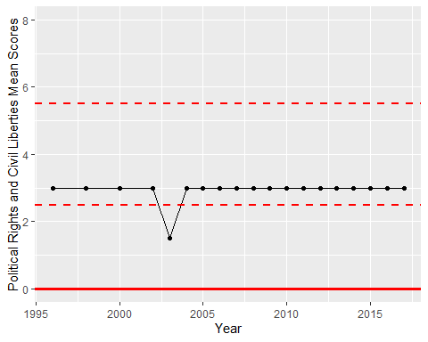

Freedom House Score Trend